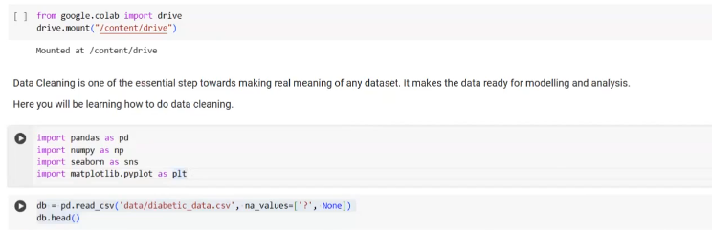

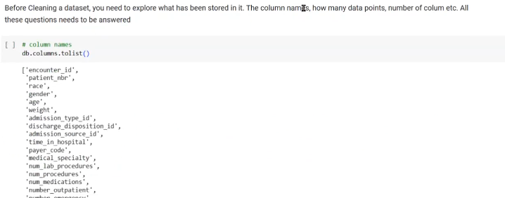

Repkace missing value with mean,median,mode:

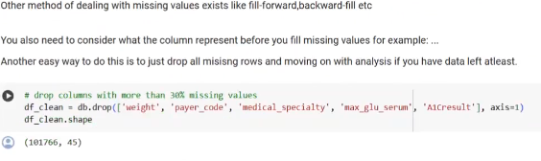

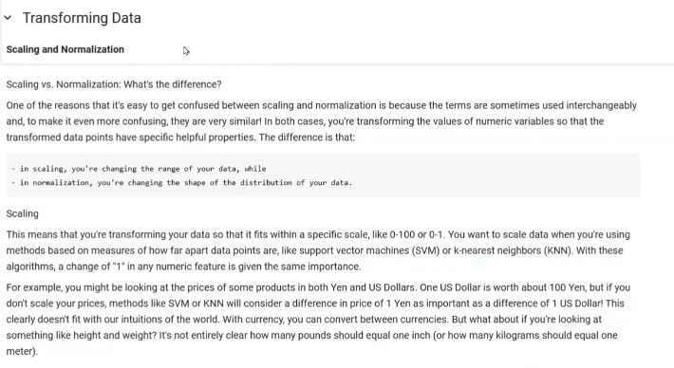

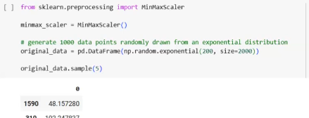

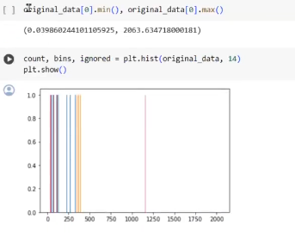

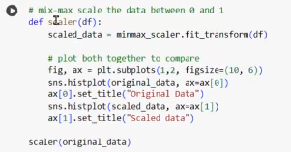

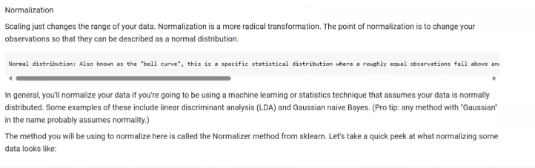

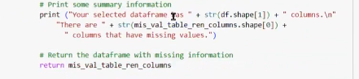

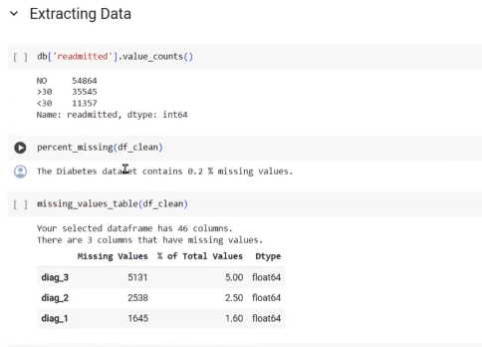

Distribution:

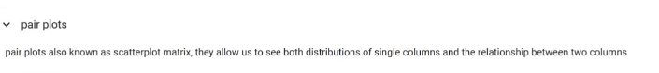

Video-13-1-24-time53.00

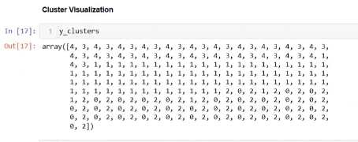

Example-code

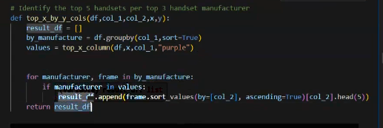



Streamlite for project-5 video-27-01-2024-42:44

